**Join us for the MISSISSAUGA**

**Accessibility Forum**

**Guest Speaker:** **David Lepofsky**

**Accessibility Advocate and Chair, AODA Alliance**

**Panel Discussion Including Community Q&A**

This interactive event is open to all people with an interest in barrier-free communities for people with disabilities.

**Tuesday April 12, 2016**

**From 7-9pm**

**Mississauga Seniors’ Centre**

**1389 Cawthra Road**

**Lucy Turnbull Room**

ASL Interpreters

Attendant Services Volunteers On Site

RSVP to Julie Hitchcock by April 11: julie.hitchcock@sciontario.org or 905-459-6965 x2

Free Parking & Public Transit Available

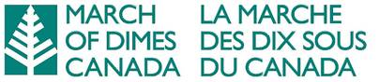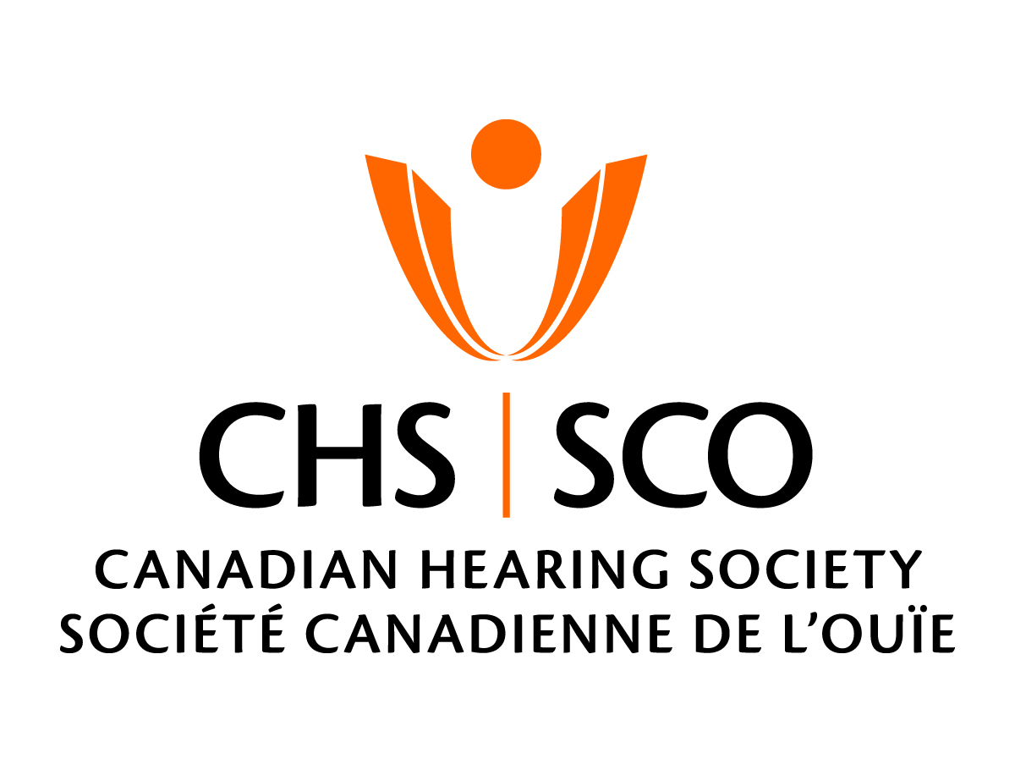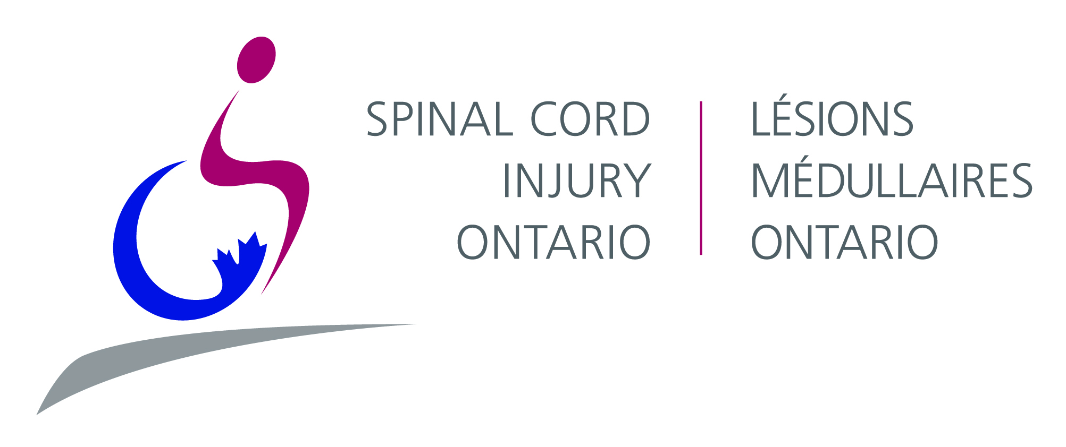**Presented by:**

**CNIB, Spinal Cord Injury Ontario, March of Dimes Canada, Canadian Hearing Society**